Load-Balancer

01) Configure Classic Load balancer.
Ans: Task Title
Configure a Classic Load Balancer in AWS
Objective:
Set up a Classic Load Balancer to distribute HTTP traffic across EC2 instances hosted in
multiple Availability Zones.
Prerequisites:
• VPC
• Public Subnets in at least 2 AZs
• EC2 Instances with web server installed
• Key Pair
• Security Groups for EC2 & ELB
• Route Tables properly associated
• AMI (Amazon Linux 2 image)
Step-by-Step Implementation (With Evidence):
First need to login to our aws console and search for vpc and create one vpc with the name of Techie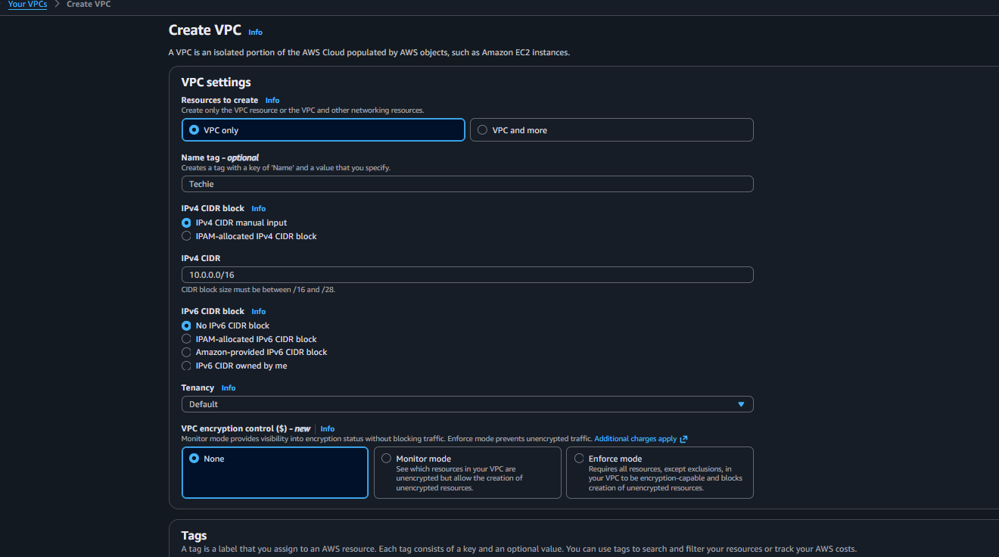
Once the vpc is been created need to create 2 public subnet with different availability zone 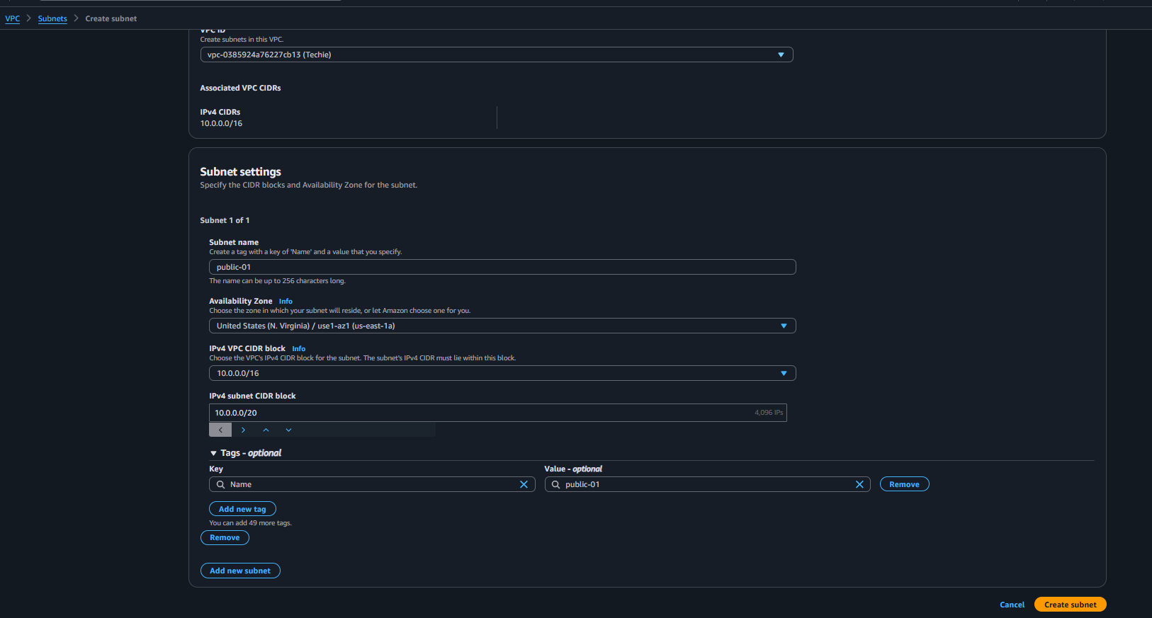
Then created the route tables for subnet and associate the subnet in route-tables 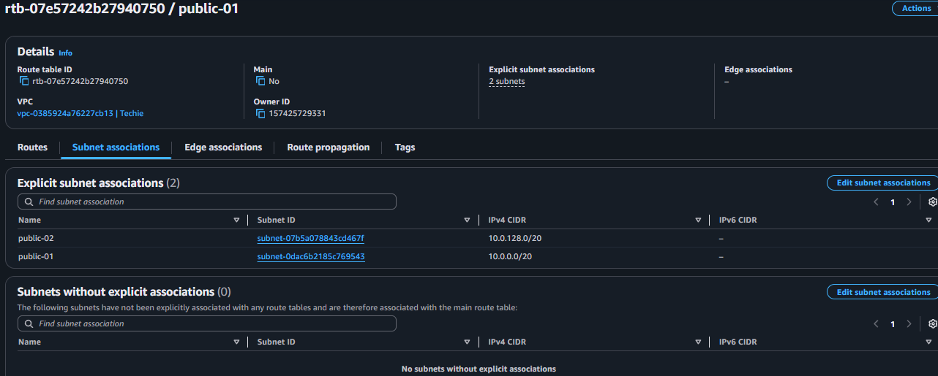
Now creating a internet gateway and adding the records in route table 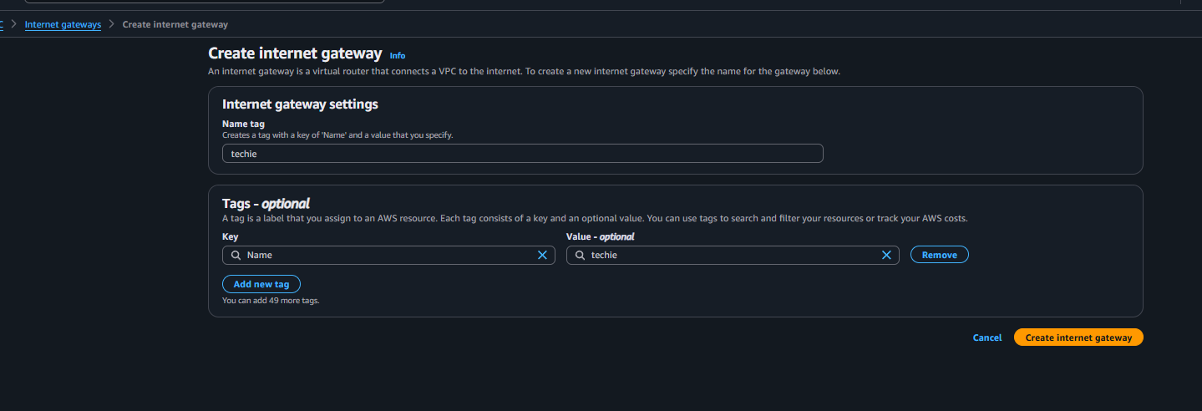
Attached the internet gateway to vpc now adding the records 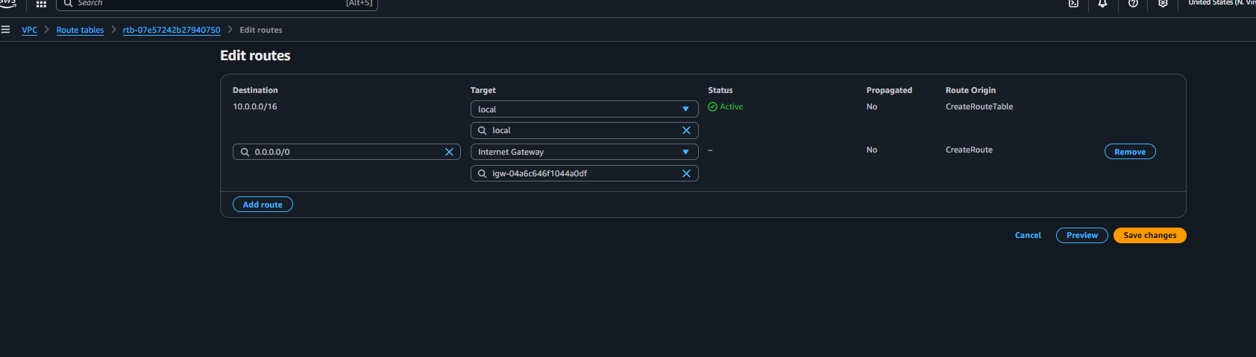
Now need to create the load balancer search for ec-2 and click on load balancer and click on classic-load balancer and creating the load balancer 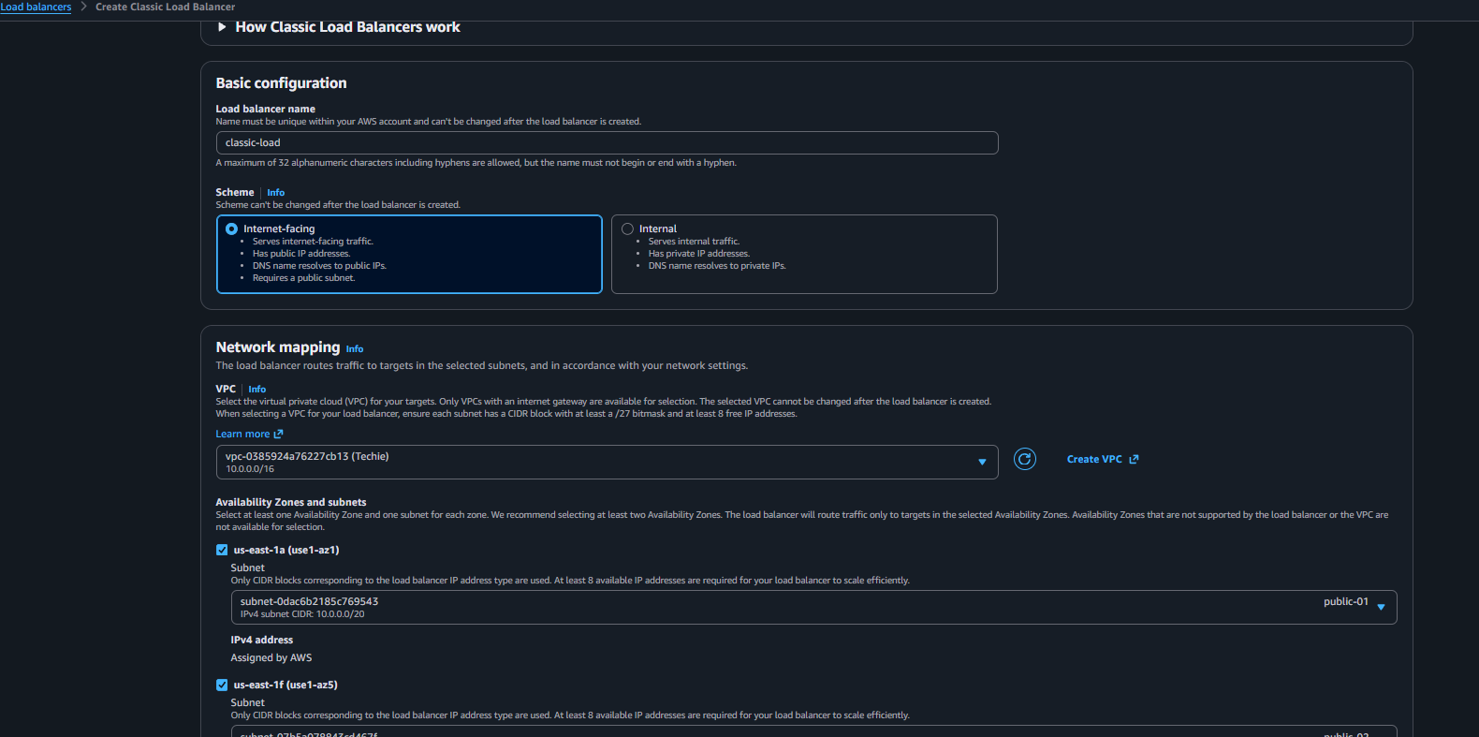
Now the load balancer is been created so we are launching 2 instance with 2 subnets and adding the httpd in user data 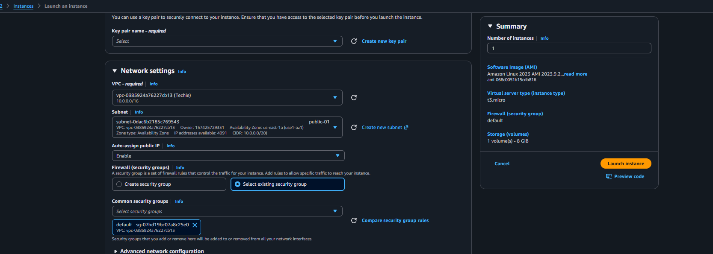
Once the instance is been launched need to add these 2 instance in classic load balancer 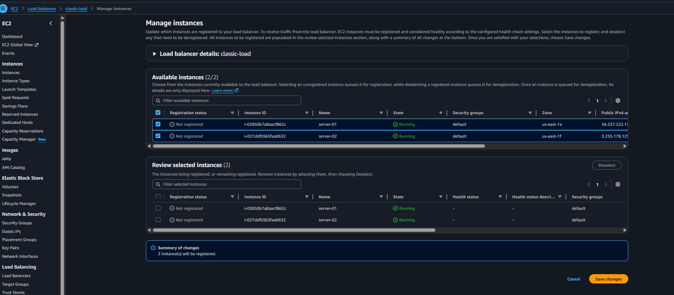

Validation : created the vpc and 2subnets 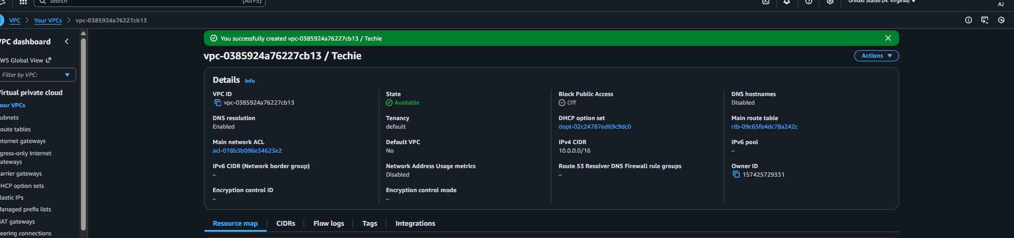
Added the internet gateway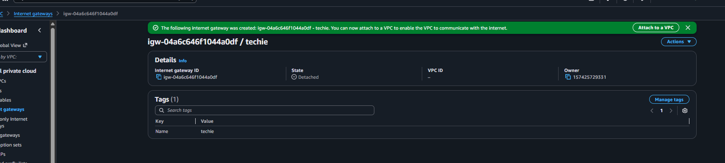
Added integrate way in 2 route tables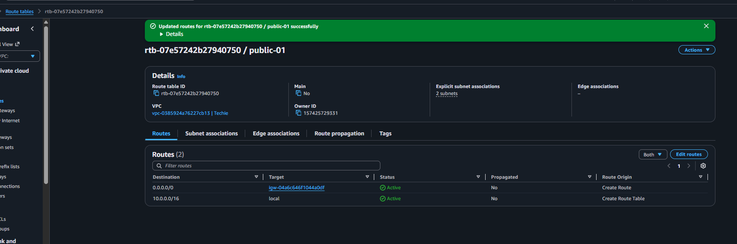
Created the classic-load balancer 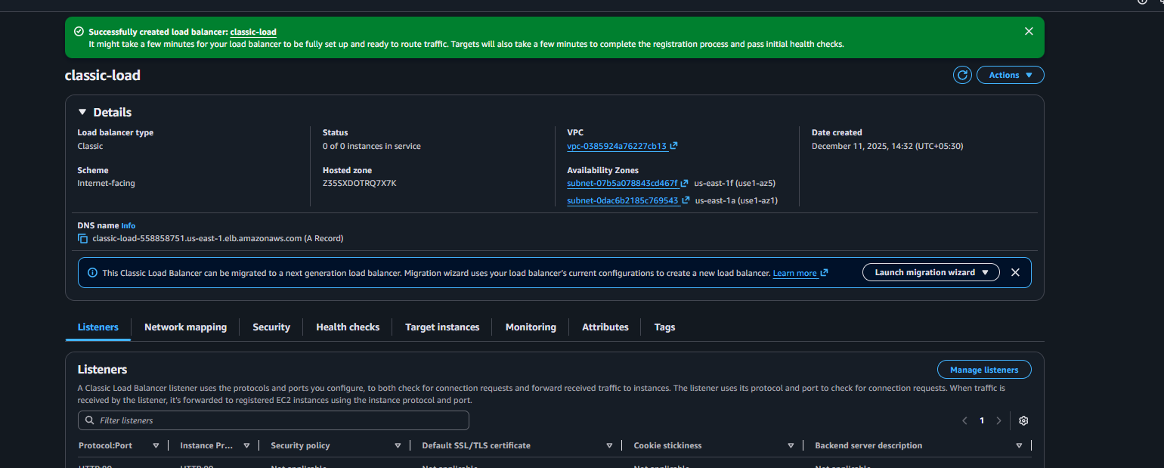
Launched 2 instance with 2 subnets 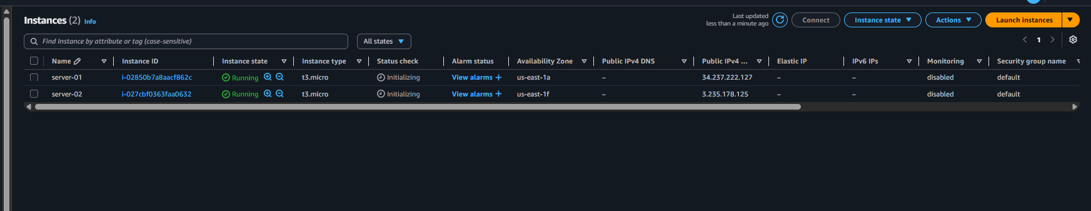
Added 2 instance in classic load balancer 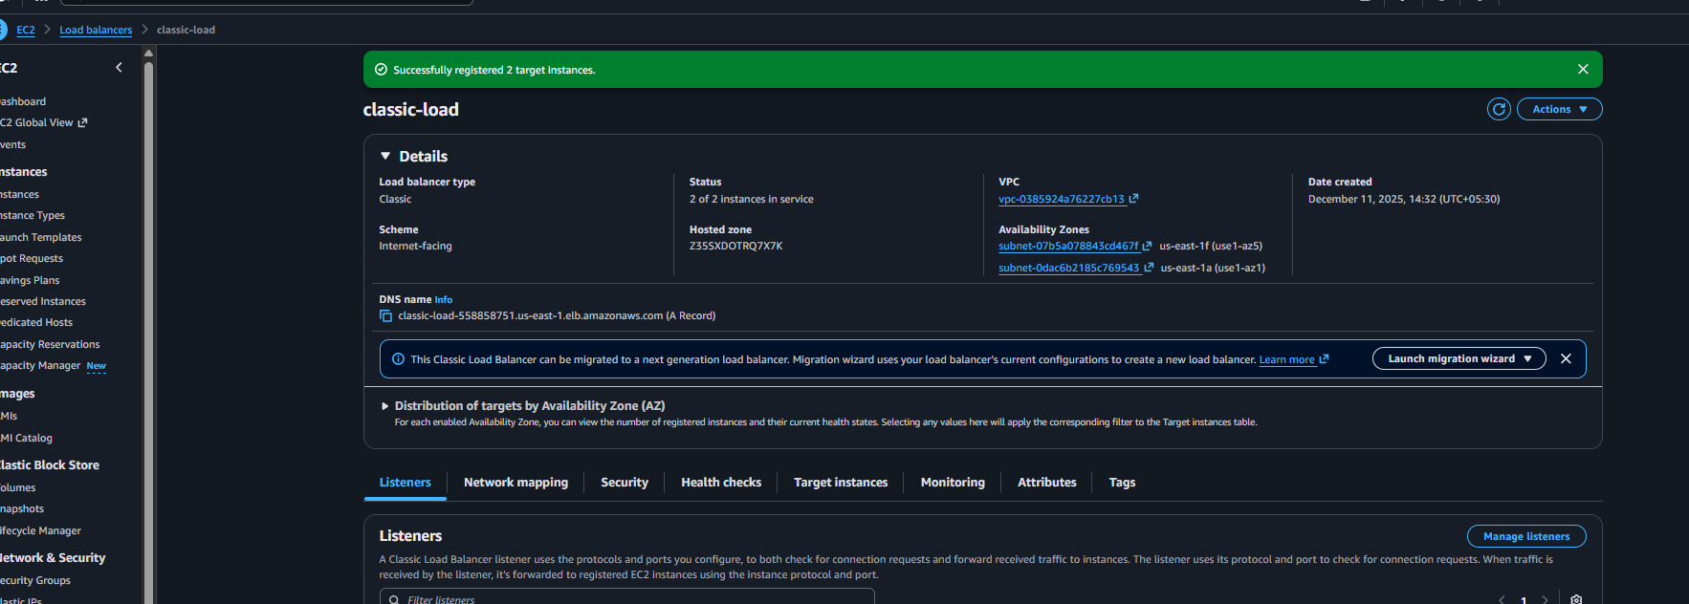
Copy the dns and paste in browser its been working 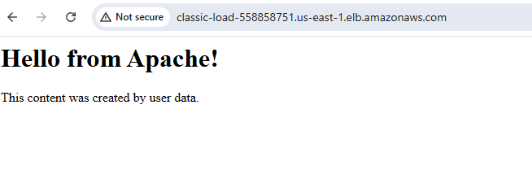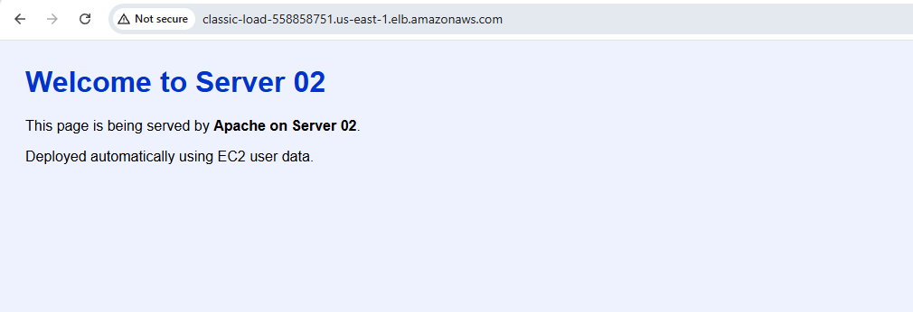

Conclusion: successfully configure the classic load balancer

02) Configure Application Load balancer.
Ans: Task Title
Configure Application Load Balancer (ALB)
Objective:
Create an Application Load Balancer to distribute HTTP/HTTPS traffic across multiple EC2
instances using Layer 7 intelligent routing.
Prerequisites:
Before starting, ensure the following are ready:
• VPC
• Public Subnets (min 2)
• IAM Role (EC2 Role – optional)
• Key Pair
• Security Groups (Allow HTTP/HTTPS)
• EC2 Instances (Web server installed)
• Route Tables configured
• Packages Installed (Apache)
• Internet Gateway attached to VPC
Step-by-Step Implementation (With Evidence):
Under the ec-2 console need to click create load balancer and select the application load balancer 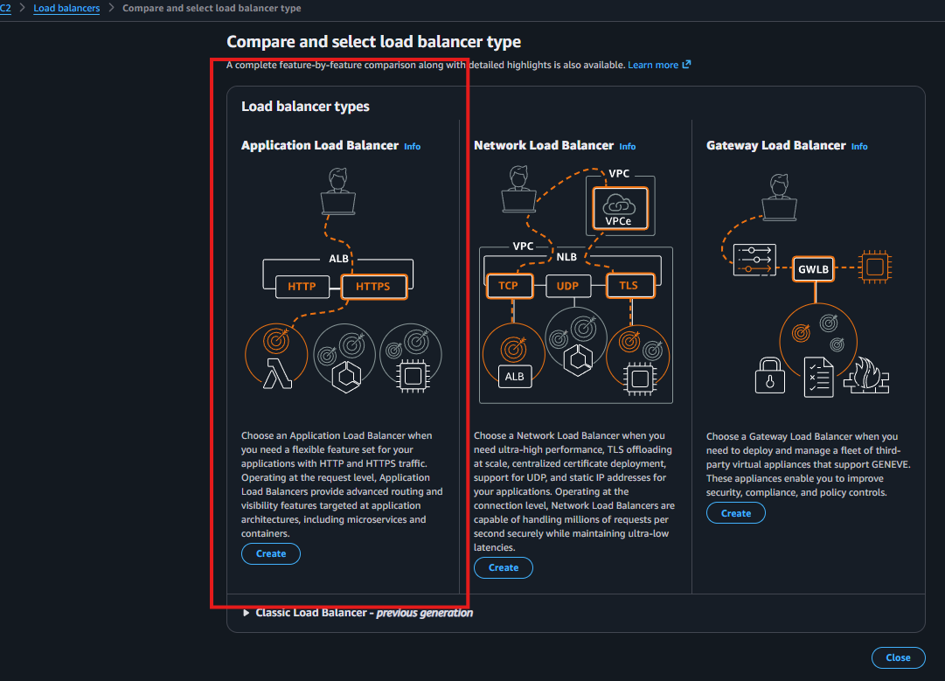
And add the details to create the load balancer entre the name and selected the vpc 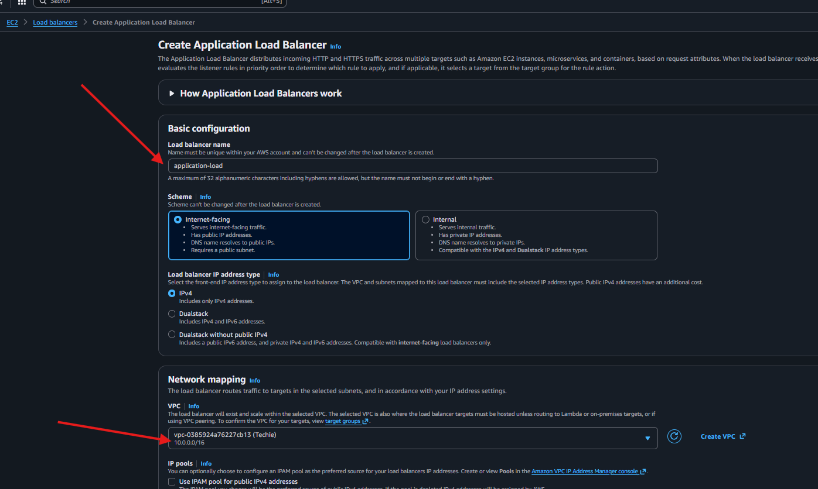
Need to select the target if target is not been created first need to create the target group 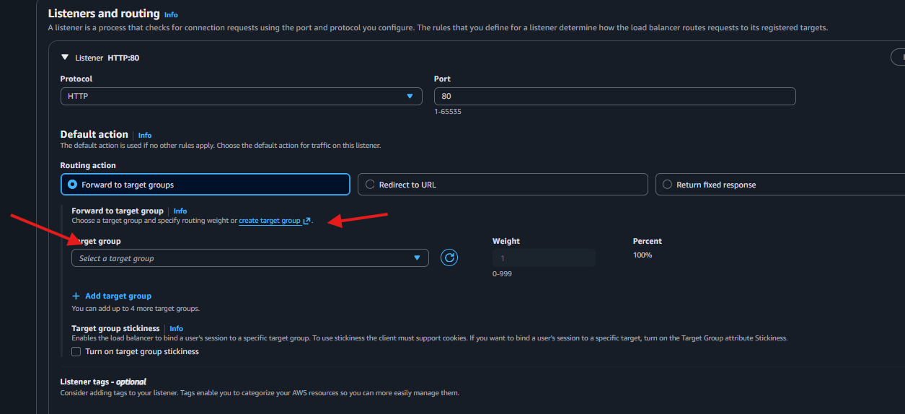
Need to enter the target group name and select the vpc 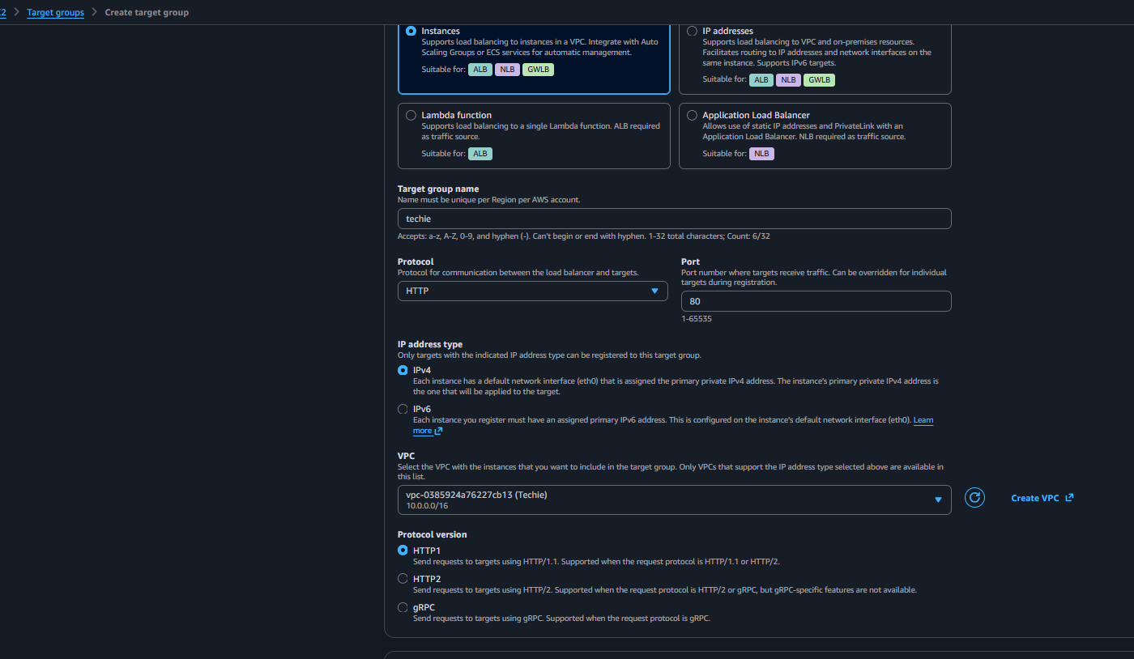
Under the 2 step need to add instance and click on next in final step need to review the details and click on create 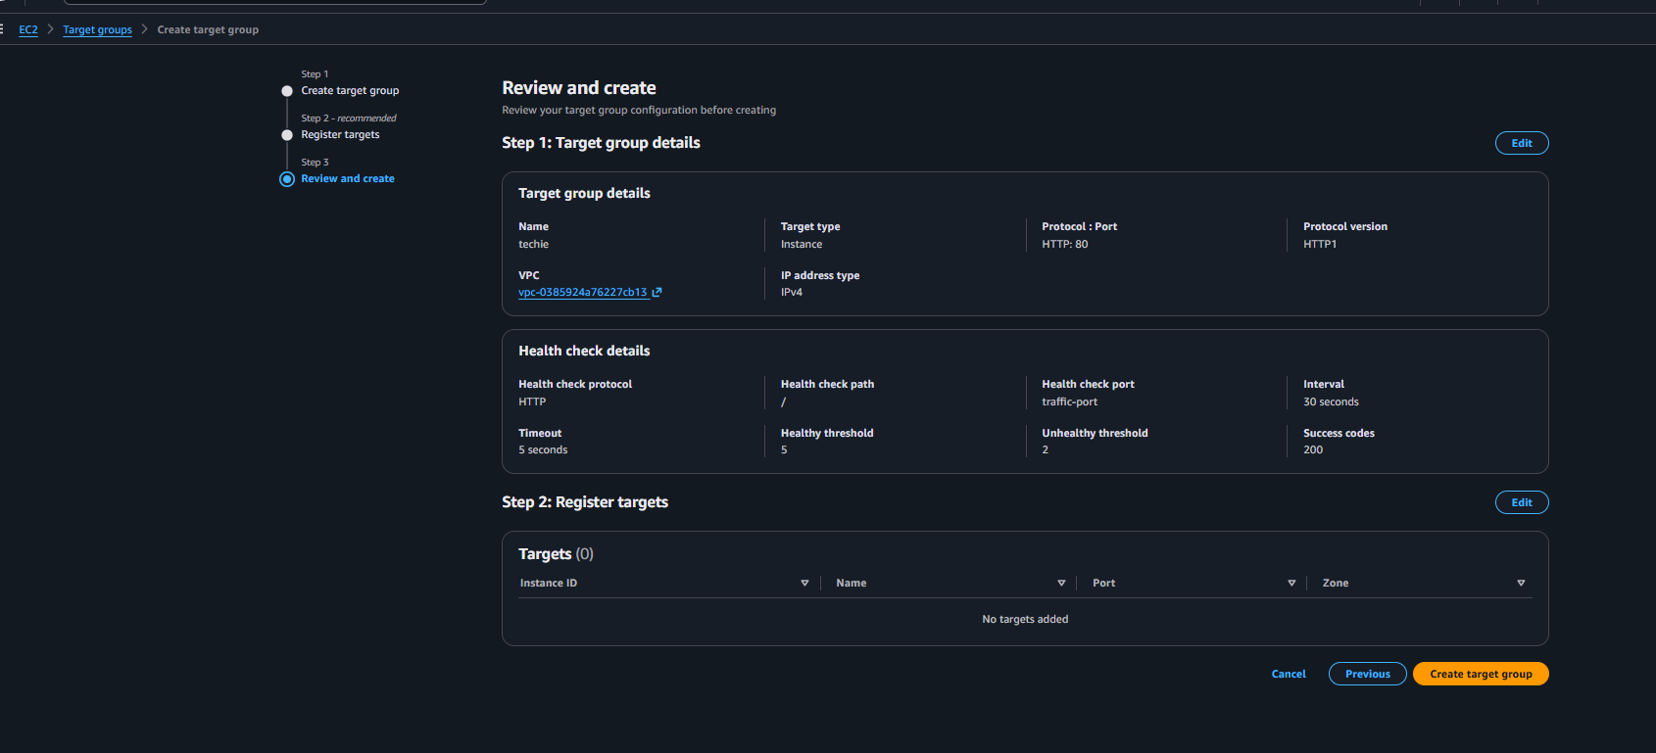
Once the target group is been created add instance in group 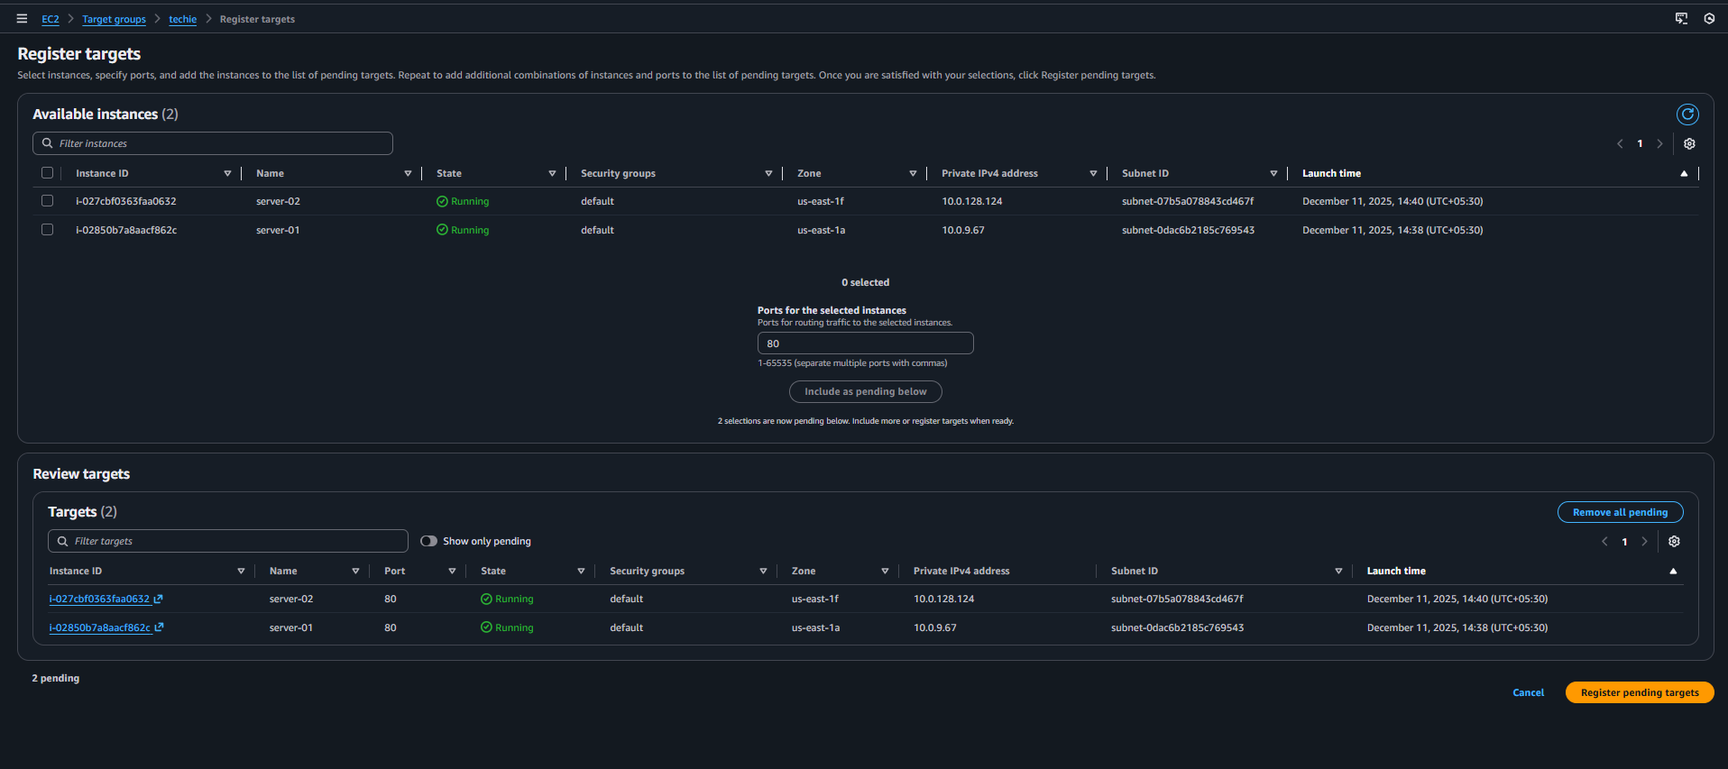
Now need to add the target group in application load-balancer 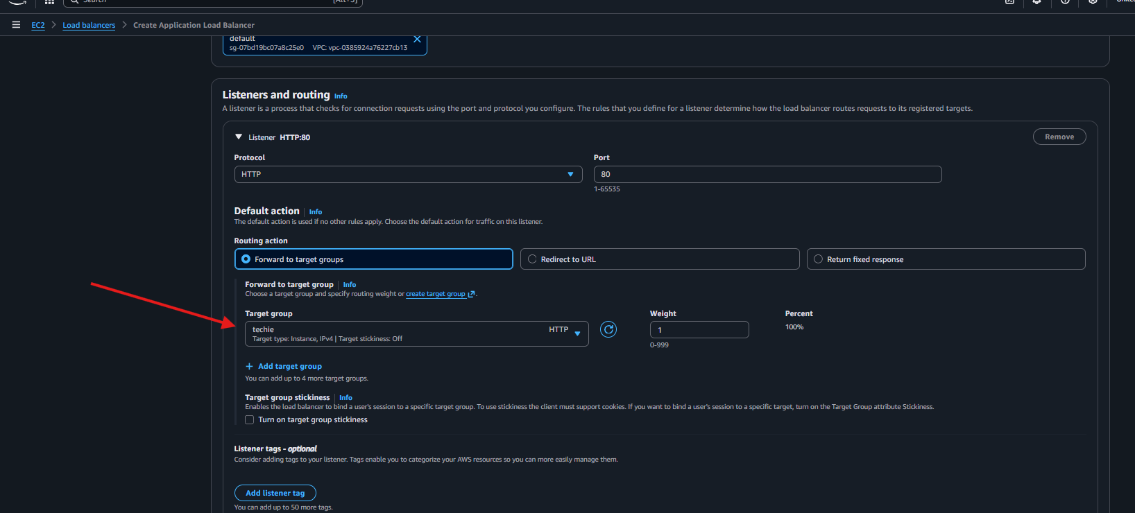
Now the application load balancer is been created

Evidence:target group is been created 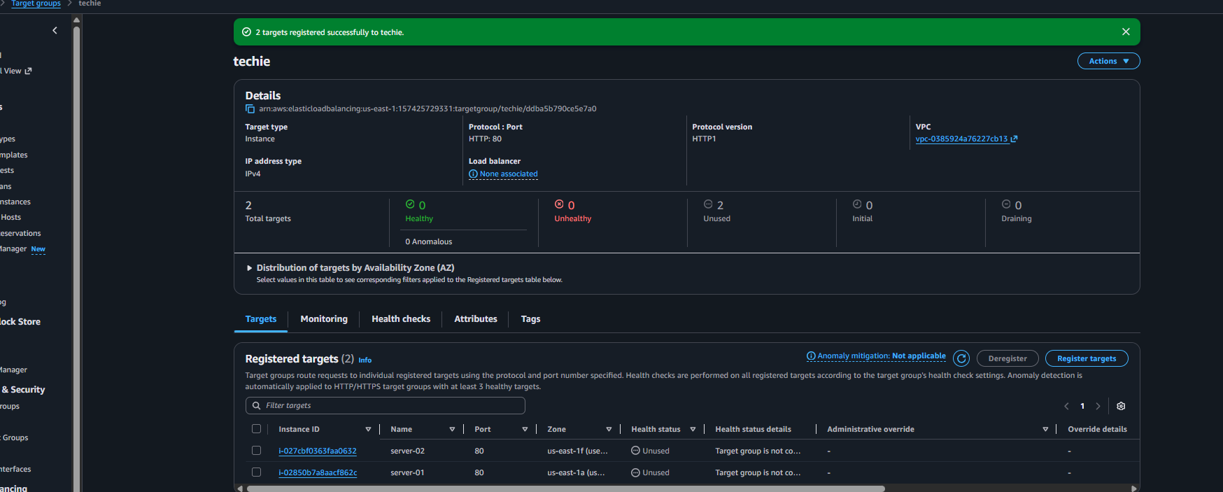
Application load balancer is been created 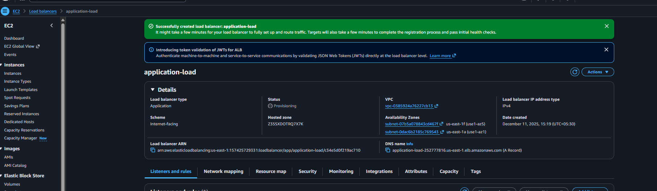
While checking with dns record in browser getting 2 server website 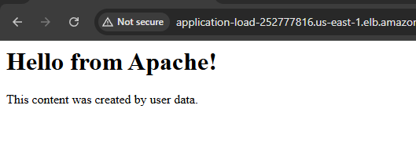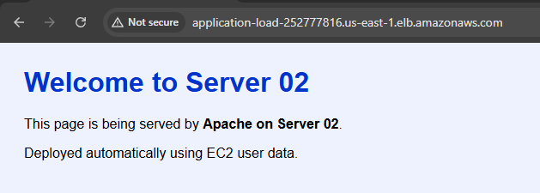

Conclusion: successfully configure the application load balancer and added the 2 instance in load balancer

03) Configure Network Load balancer.
Ans: Task Title
Configure Network Load Balancer (NLB) in AWS
Objective:
Set up a high-performance Layer 4 Network Load Balancer to distribute TCP traffic across
EC2 instances with extremely low latency.
Prerequisites:
• VPC (default or custom)
• Public Subnets in at least two
• Elastic IP addresses
• EC2 Instances (web server httpd)
• Security Groups for EC2 (NLB doesn’t use SGs)
• Key Pair (avengers.pem)
• Route Tables
Step-by-Step Implementation (With Evidence):
To create network load balancer need to go on ec-2 console and click on load balancer and click on create load balancer 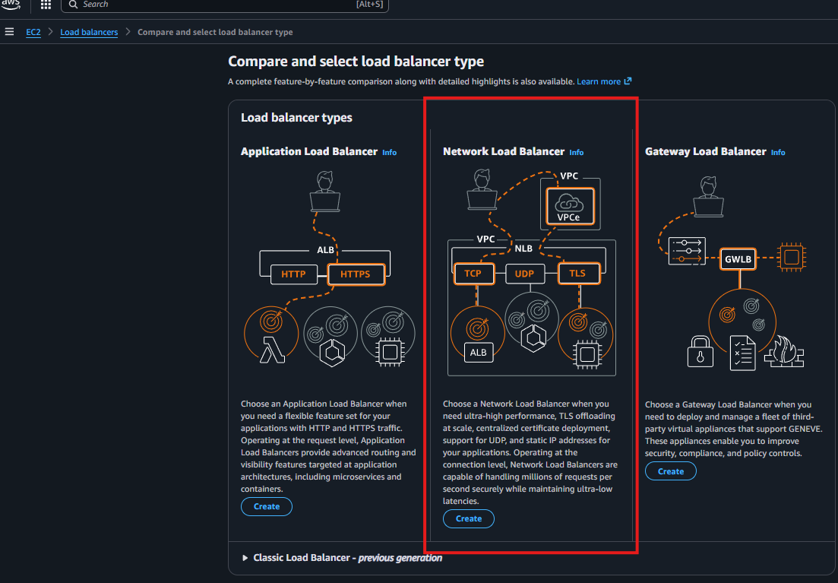
Then need to click on create and name the load balancer 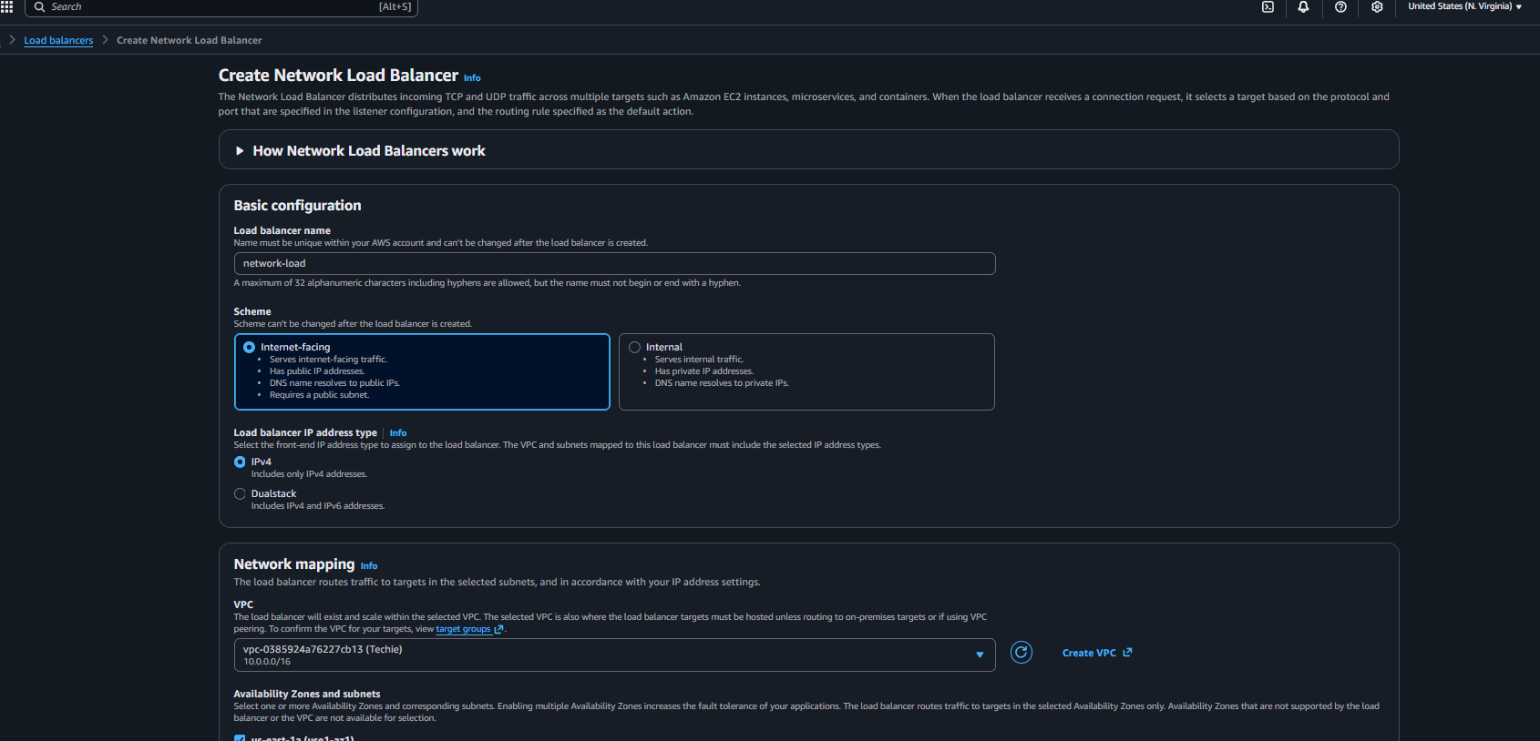
In network load-balancer we have option to add elastic ip so we are creating elastic ip first nee to go vpc console and click on elastic ip
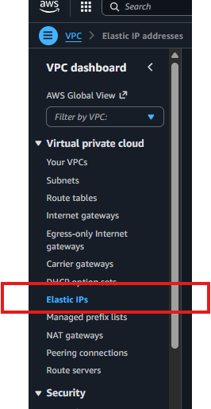
And need to click on create elastic ip 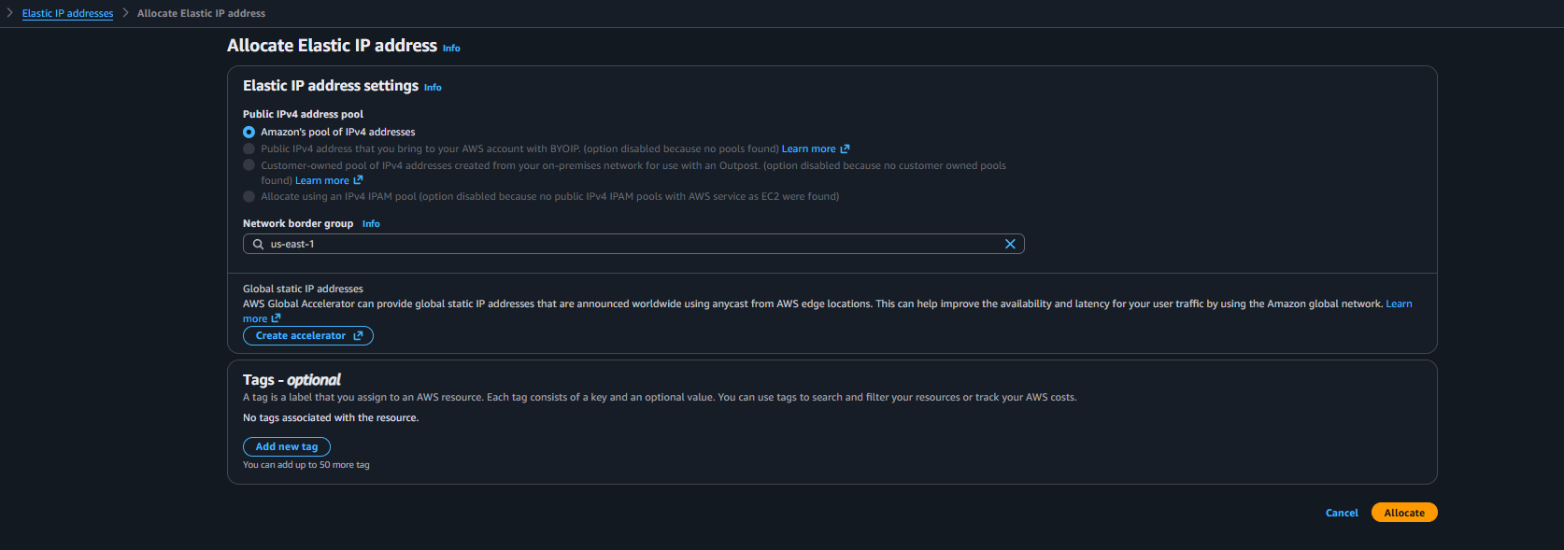
Once the elastic is been created now need to go back to load balancer and select the elastic ip
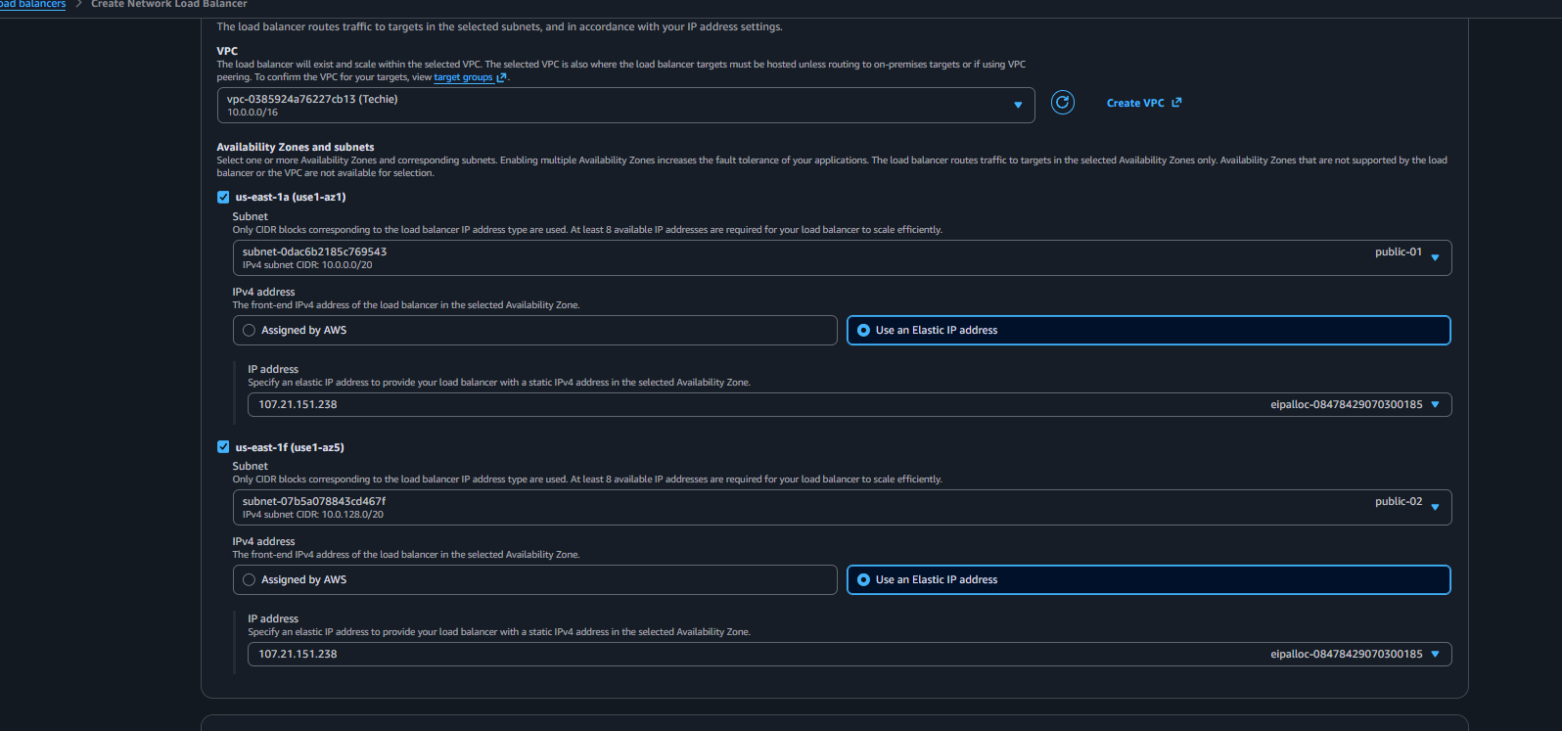
Need to select on one subnet for elastic ip and need to create the target group 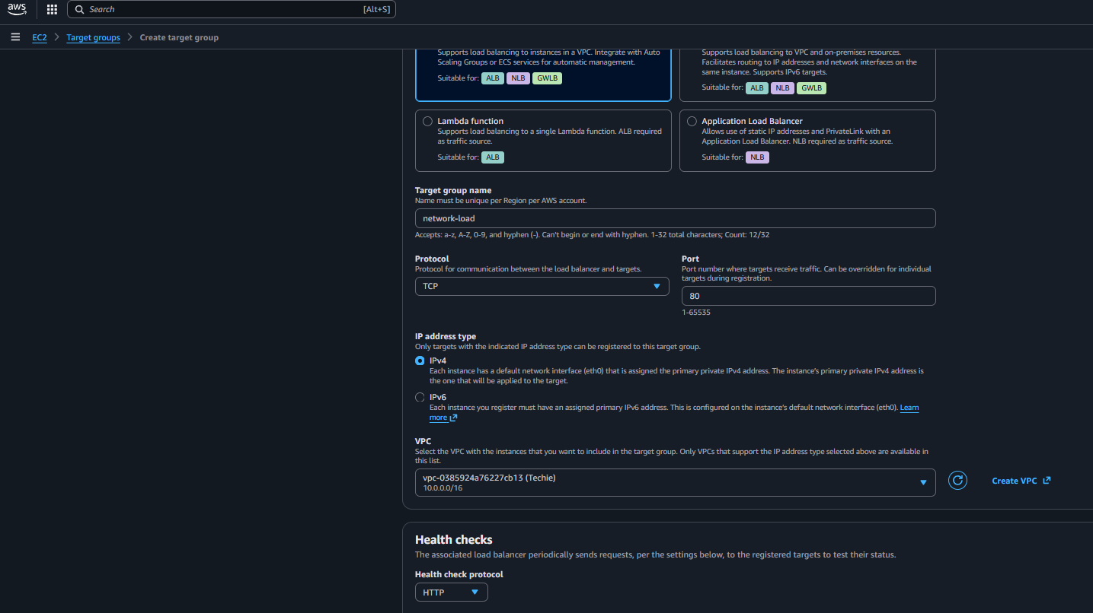
And added the instance and click on create 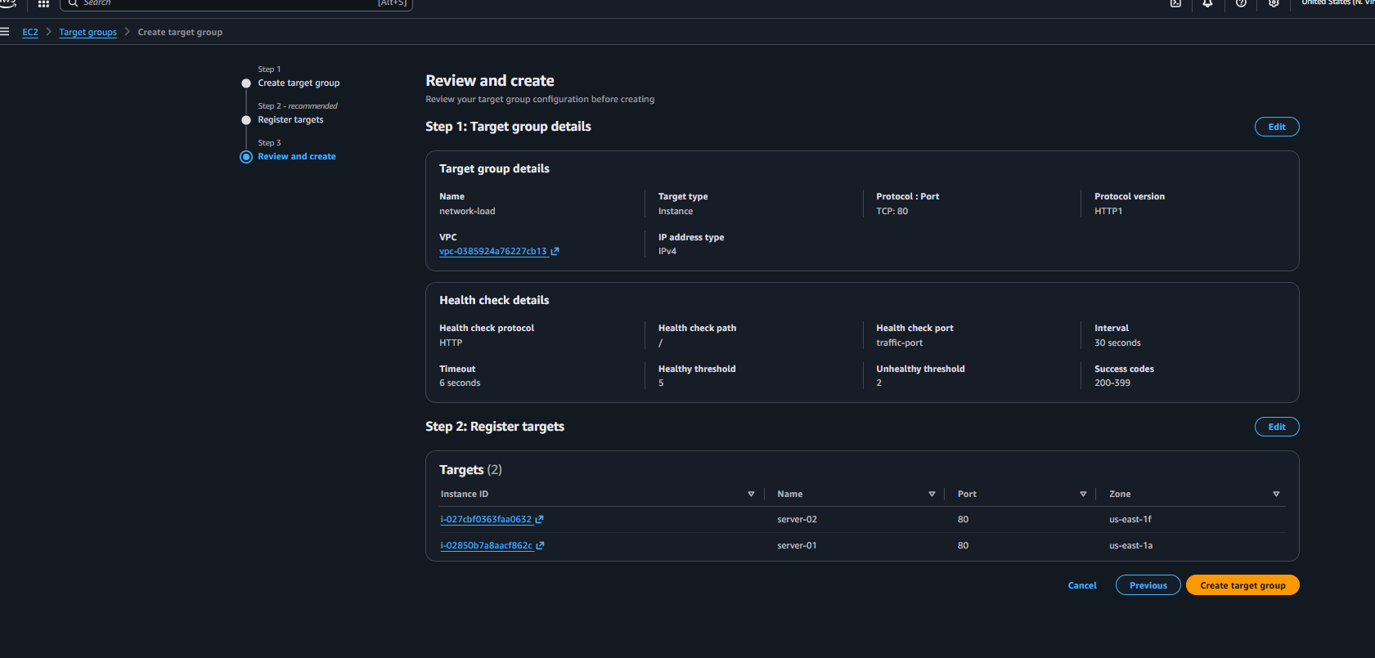
Created the load balancer 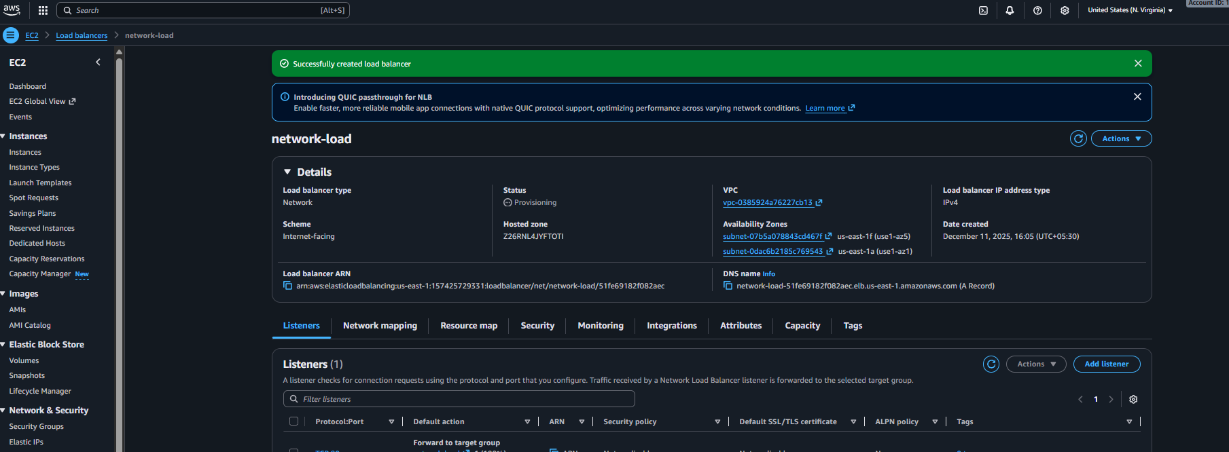

Evidence: created the elastic the ip 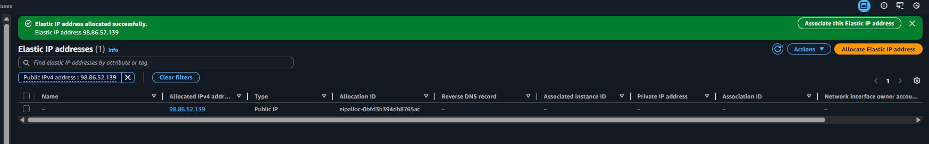
Created the target group 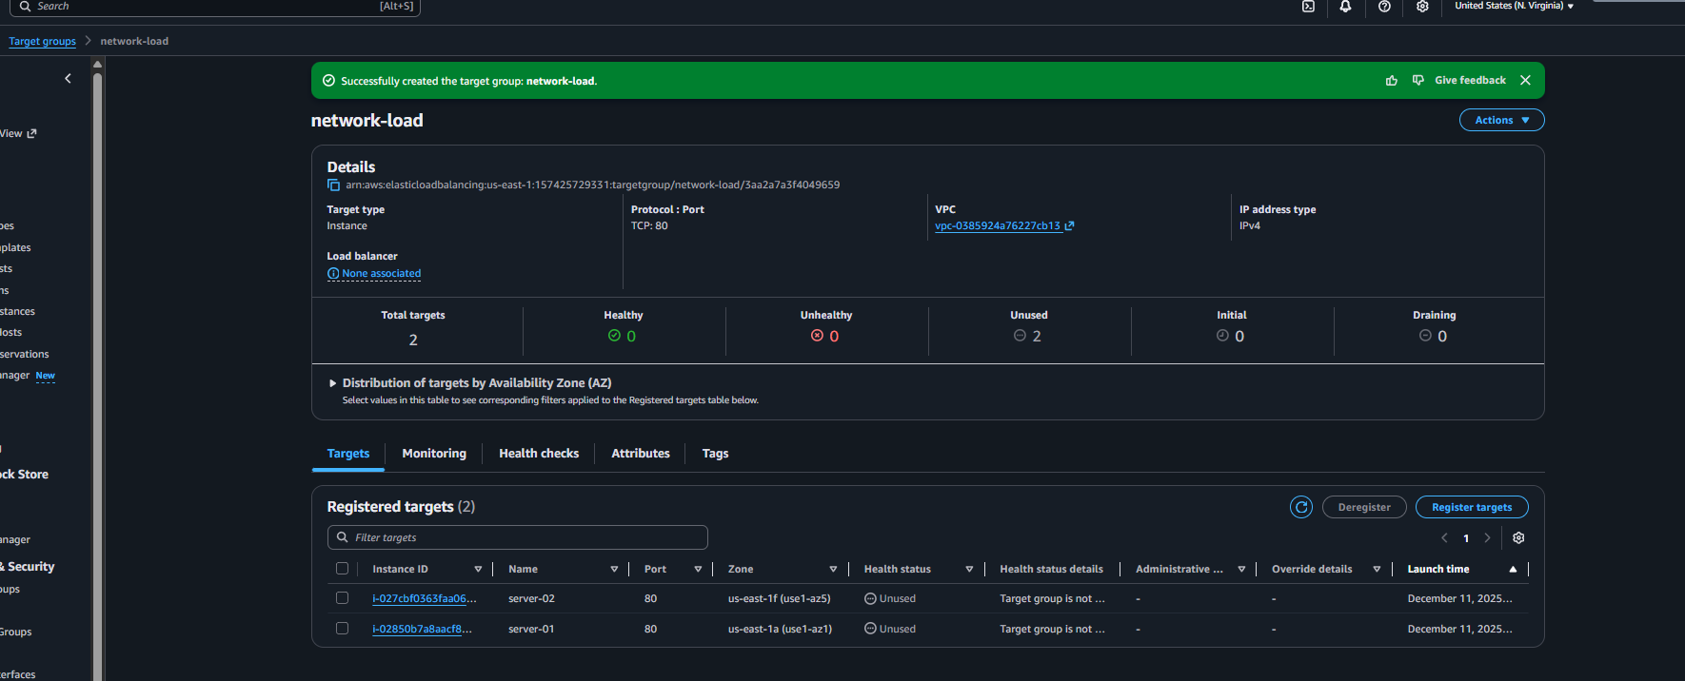
Created the network load balancer

Check the website through the dns record 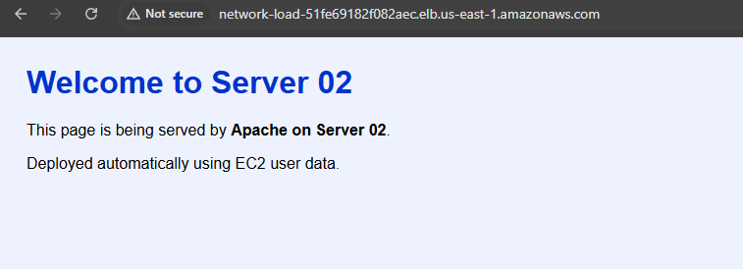
And with the help of elastic ip can able to check the server one website 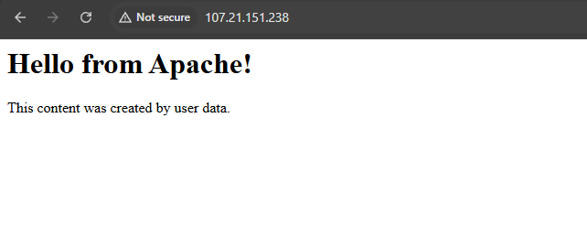

Conclusion: we have successfully configure the network load balancer
04) Attach SSL for application load balancer.
Ans: Task Title:
Attach SSL Certificate to an Application Load Balancer (HTTPS Listener Configuration)
Objective:
Enable secure encrypted communication (HTTPS) on an Application Load Balancer using an
SSL/TLS certificate issued by AWS Certificate Manager (ACM).
Prerequisites:
Before starting, ensure the following:
• VPC
• Public Subnets (at least 2 for ALB)
• Application Load Balancer already created
• Target Group created and attached
• Domain Name (shaikhshahbazz.online)
• Hosted Zone in Route 53
• ACM Certificate (Pending or Issued)
• Security Group allowing port 443
• IAM permissions for ACM + ELB
Step-by-Step Implementation:first I have the purchase the domain and once it got purchased need to go on route 53 and click on hosted zone 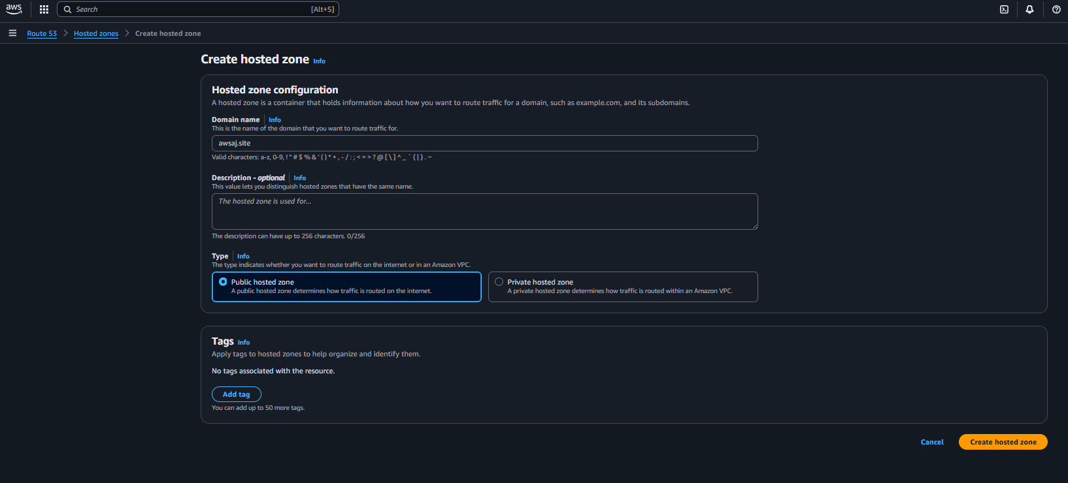
And added the nameserver in domain dns once the domain dns is been changed need to go on AWS certificate manager 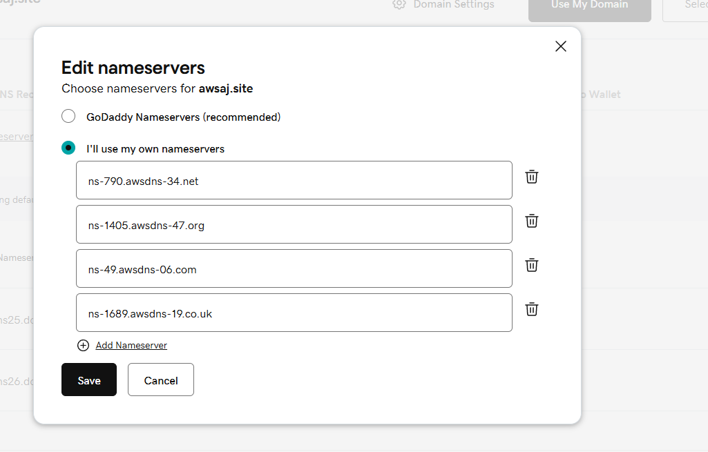
And added the ssl certificate 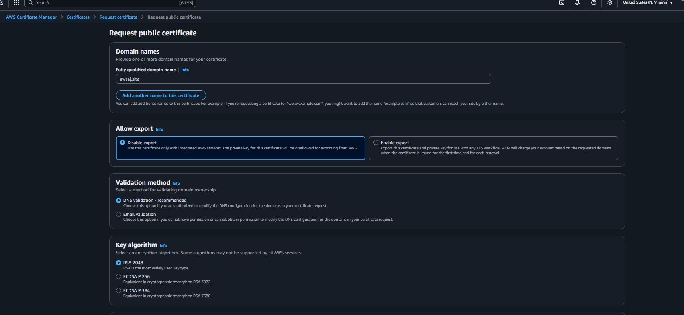
Once the certificate is been created need to add the cname record in Route53 dns 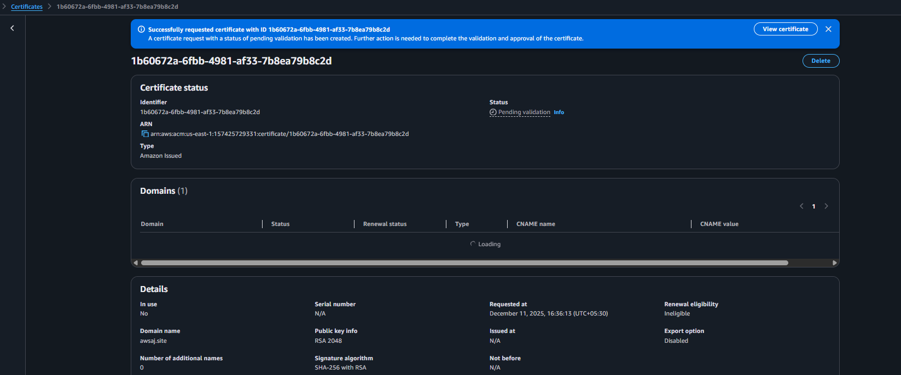
Once the record is been added now need to go for application load balancer and click on add listener 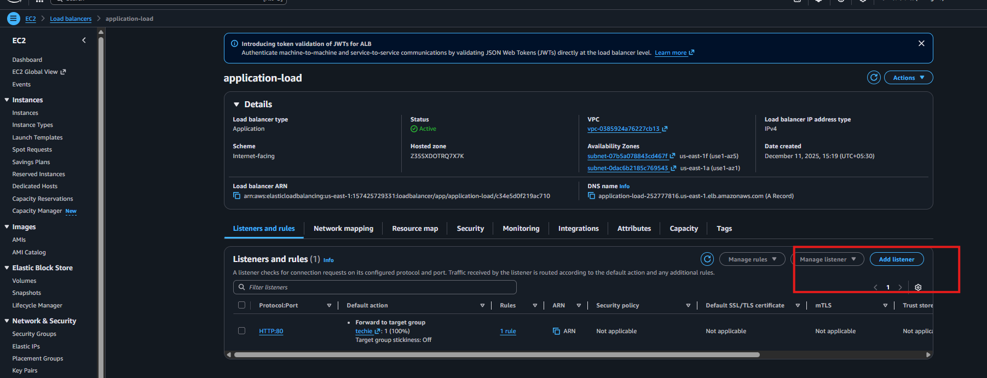
Then need to select the https in add listener 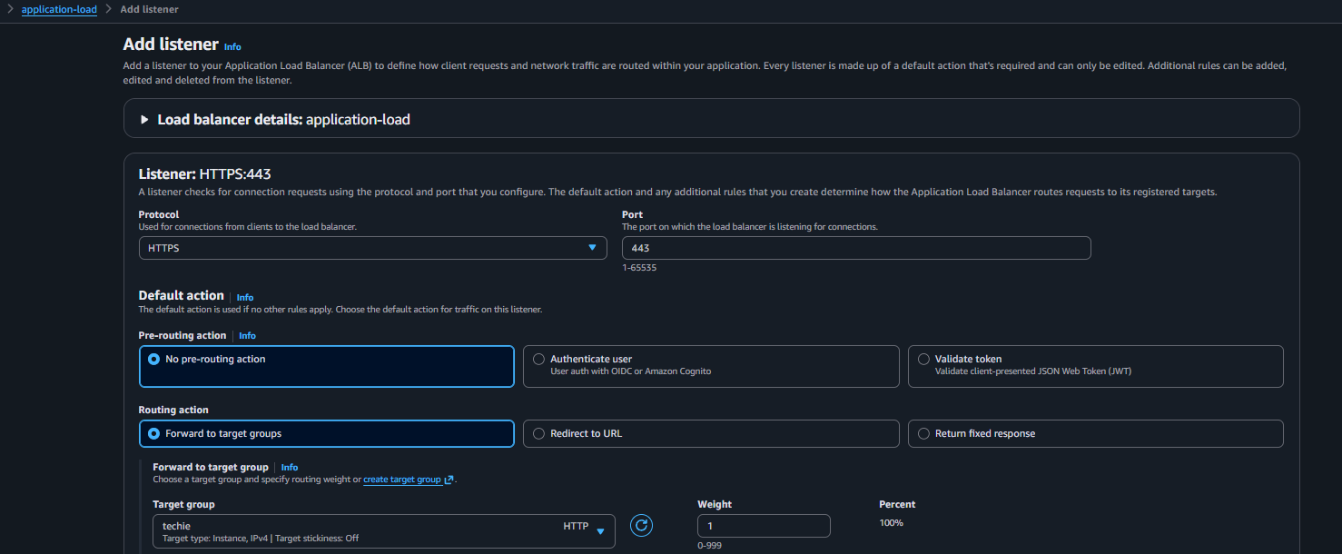

Evidence:
Changed the hostedzones for the domain
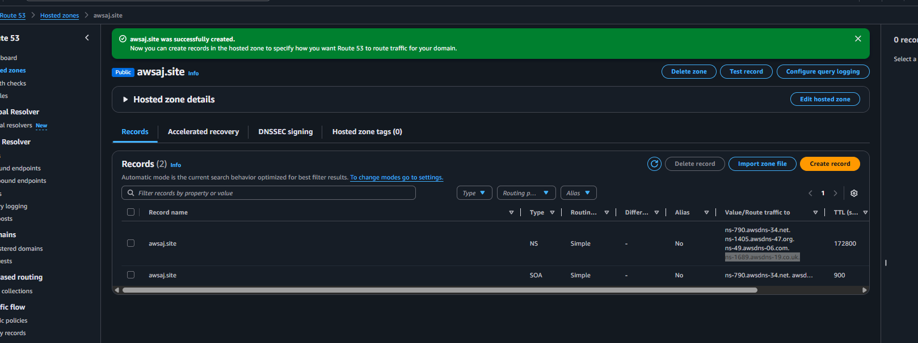
Generate the ssl certificate for the domain 
Added the dns records for ssl validation 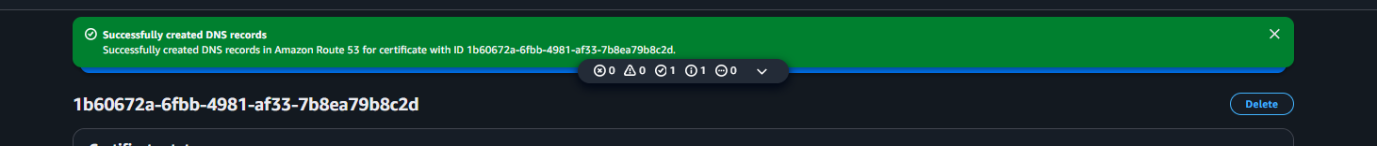
Ssl certificate is been issued 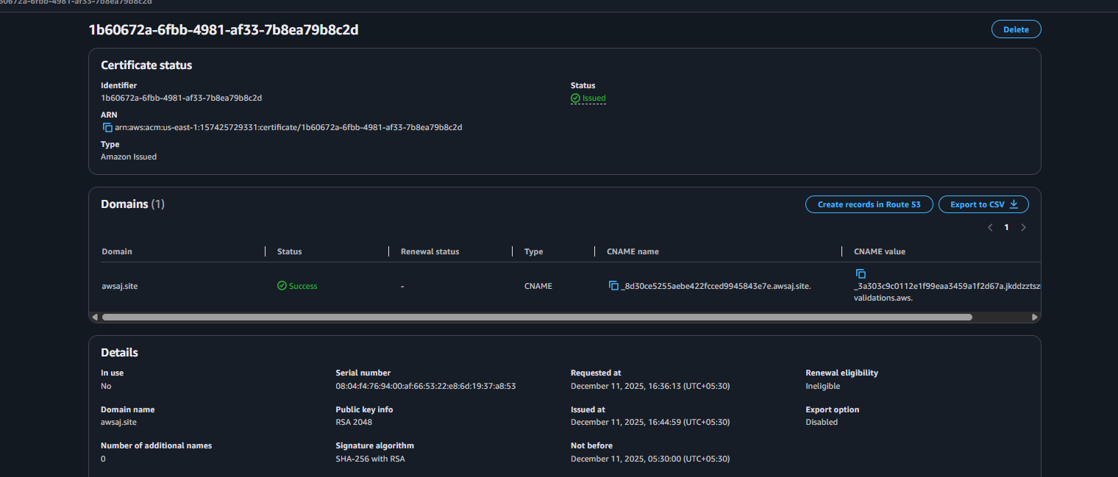
Under the application load balancer successfully added the listener 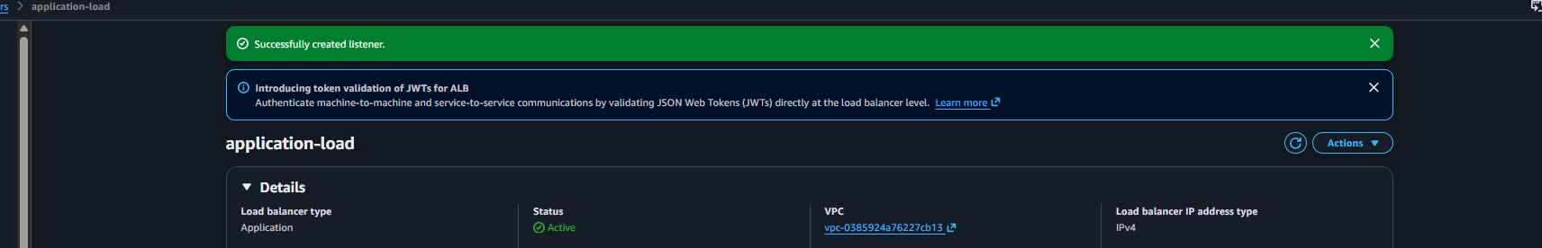

Consulsion: successfully added the ssl certificate on application load balancer

05) Map Application load balancer to R53.
Ans: Task Title
Map Application Load Balancer to Route 53 Hosted Zone

Objective:
Point a custom domain (example: www.shahbazz.com) to the ALB DNS using Route 53 so users can access the application through a clean domain instead of the long ALB hostname.

Prerequisites:
- VPC
- Public Subnets (ALB must exist in at least 2 AZs)
- Application Load Balancer (already created)
- Target Group attached to ALB
- Route 53 Hosted Zone (Domain registered in Route 53 or external domain with NS mapped)
- Security Groups
- IAM Permissions for Route 53, ELB
- SSL Certificate (optional if HTTPS used)

Step-by-Step Implementation: first need to go on route 53 and select the domain and add A record with alias of load balancer 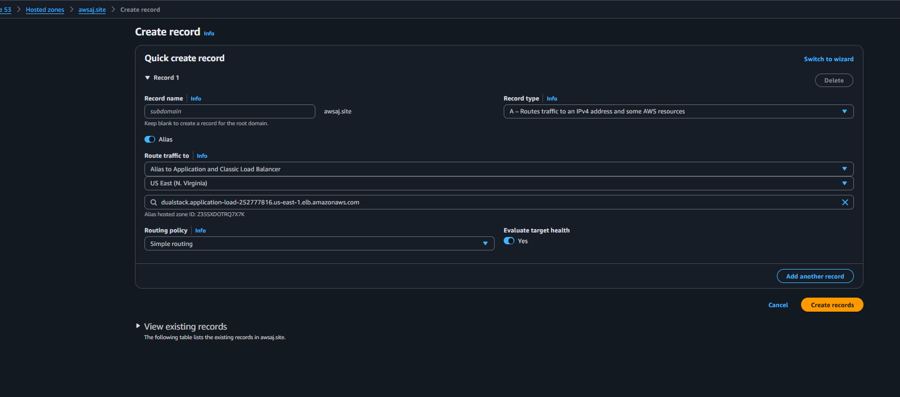

Evidence: once the A record is been added successfully 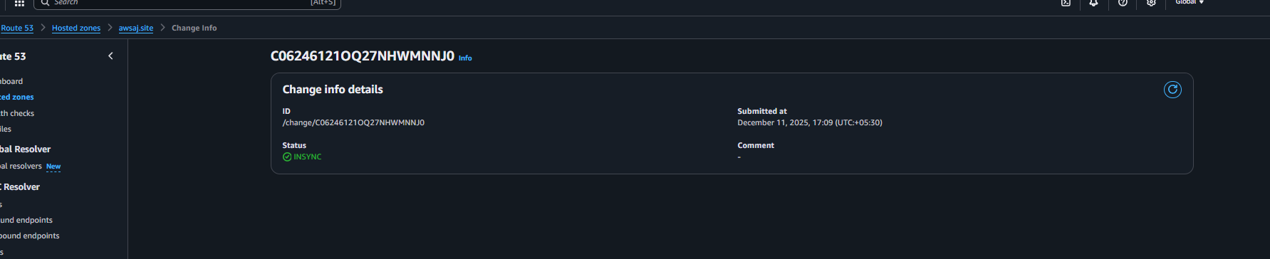now we can check the website with the domain name 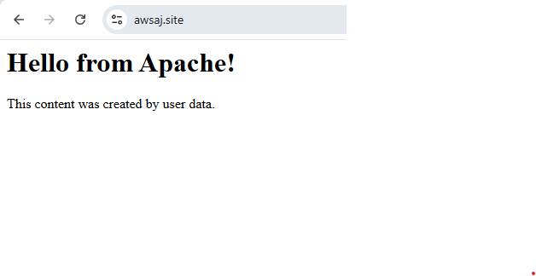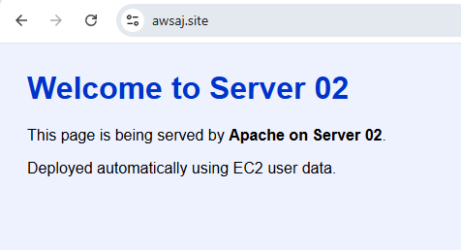

Conculsion: application load balancer is been attached with the domain name

06) Push the application load balancer logs to S3.
Ans: Task Title
Enable and Store Application Load Balancer (ALB) Access Logs in S3 Bucket

Objective:
Configure ALB access logs to automatically store request data (source IP, target IP, response time, latency) into an S3 bucket for auditing, analysis, and security compliance.

Prerequisites:
- VPC
- Public Subnets
- Existing Application Load Balancer
- S3 bucket created for logs
- Correct bucket policy for ELB logging
- IAM Permissions:
  - s3:PutObject
  - s3:GetBucketPolicy
  - elasticloadbalancing:*
- Route Tables
- Security Groups

Step-by-Step Implementation (With Evidence):
To able to push the application load balancer logs in s3 first we have to create a bucket in S3
Beed to search for s3 in aws console 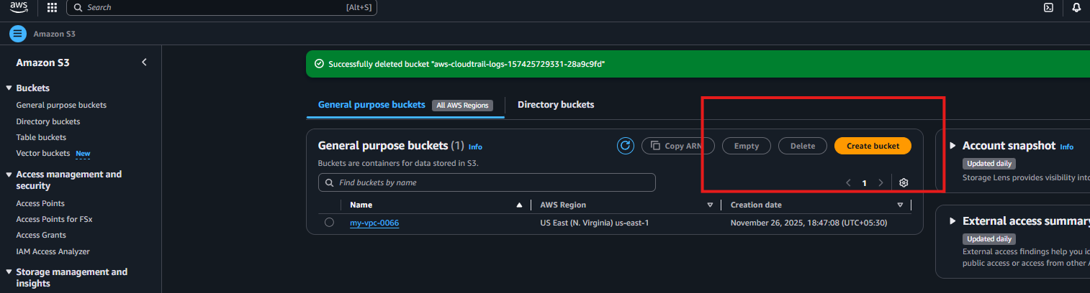
Now need to click on create the bucket 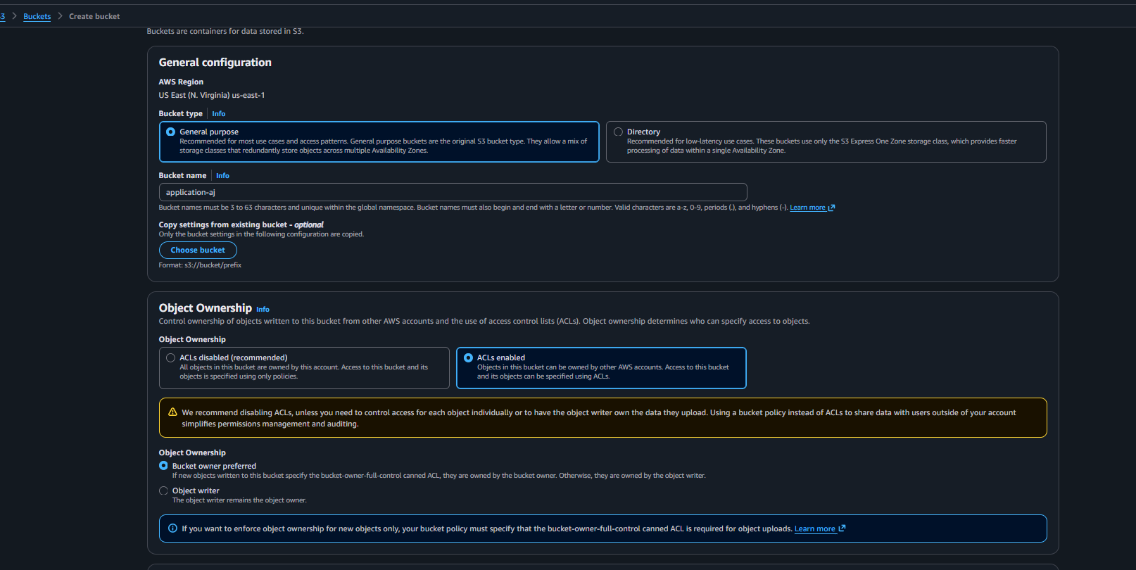
Now need to give the permission in bucket and add the code 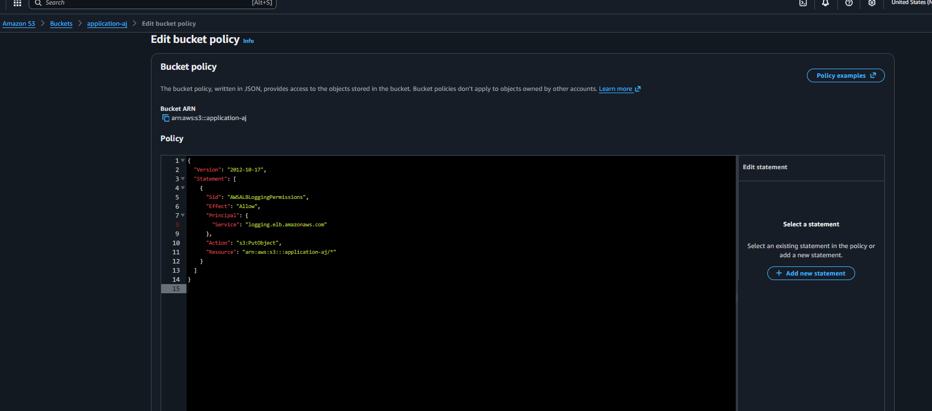
And save the permission now need to go on application load balancer click on attribute and enable the logs and select the s3 bucket save the attributes 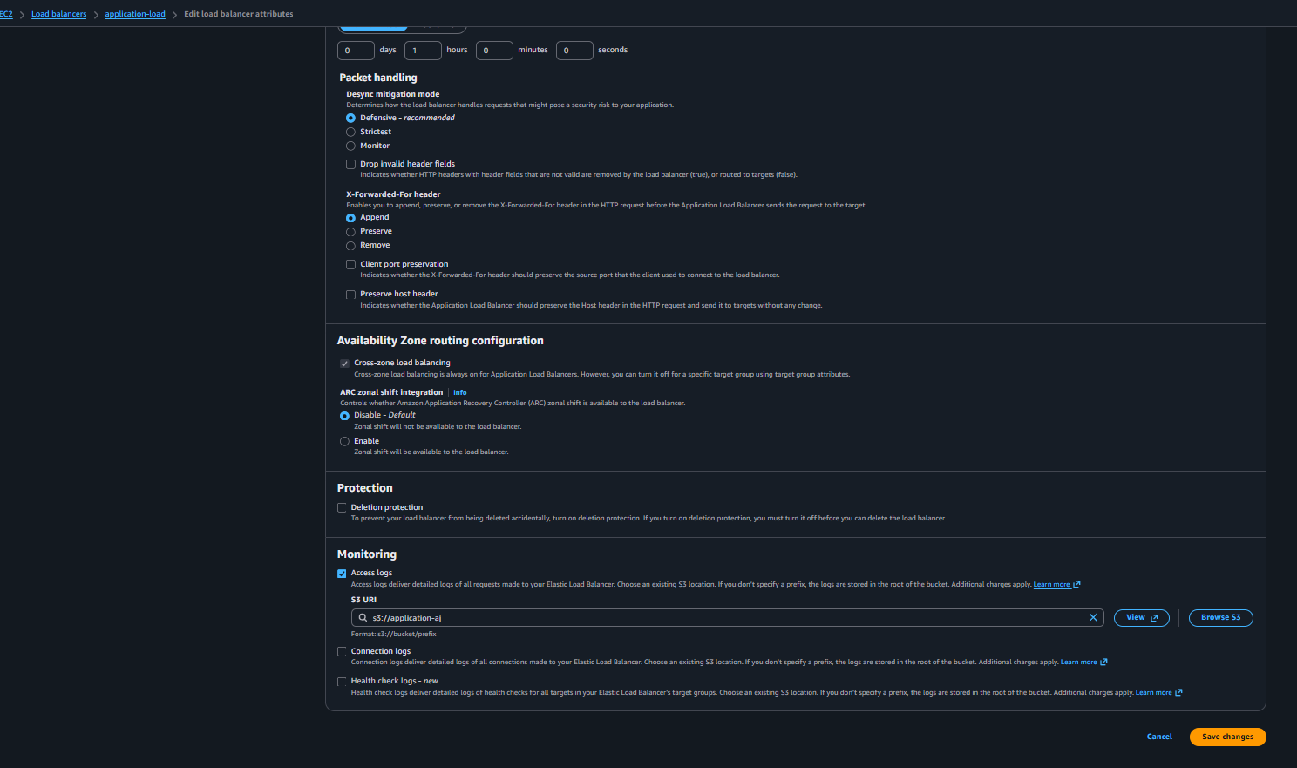

Evidence: created new bucket 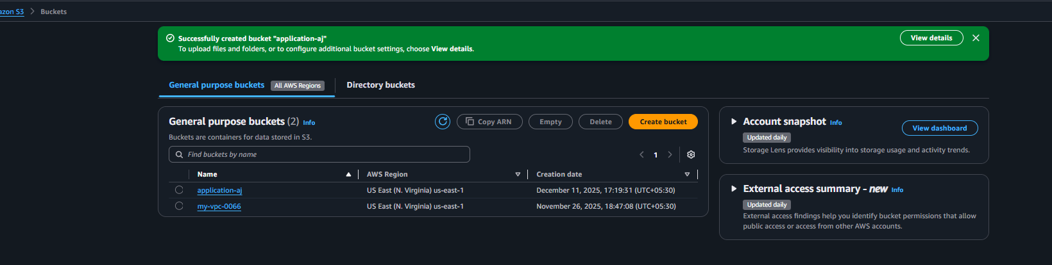
Save the correct permissions for s3 bucket 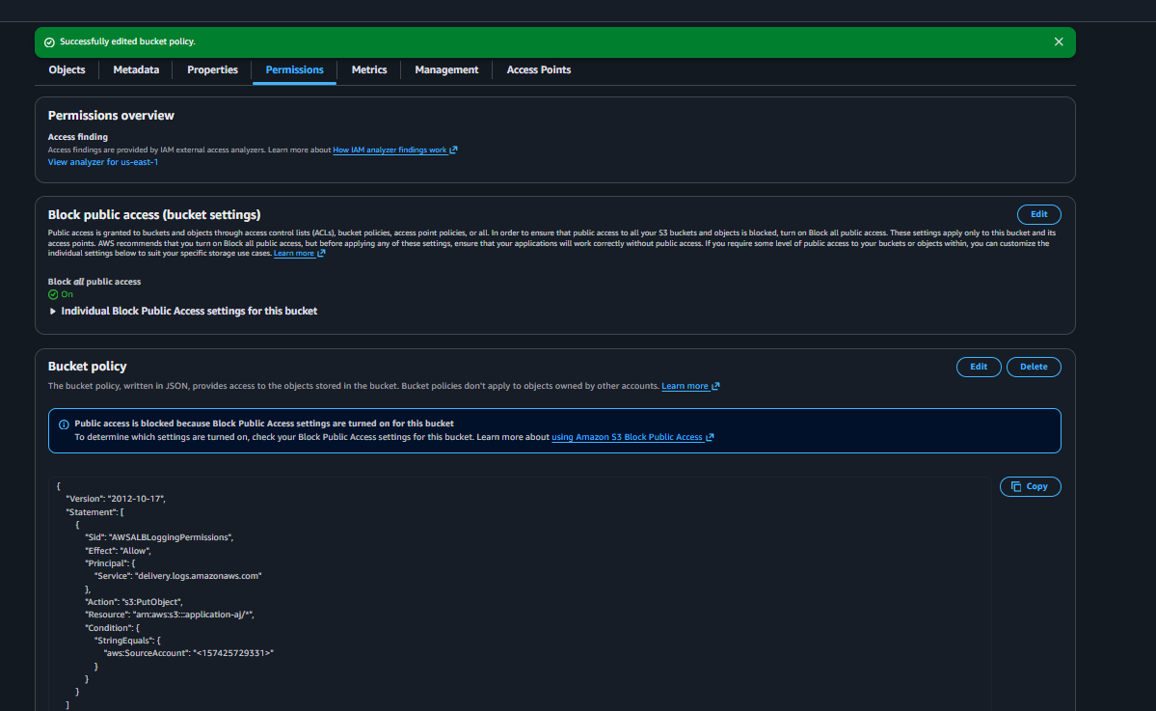
And changed the attributes and enabling the access logs 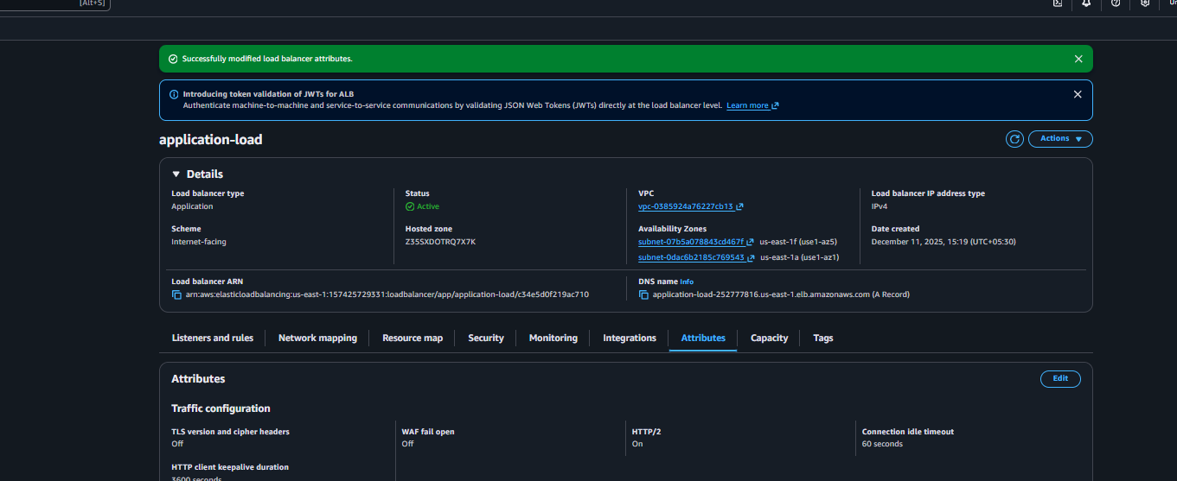
And able to check the logs for application laod balancer in s3 bucket 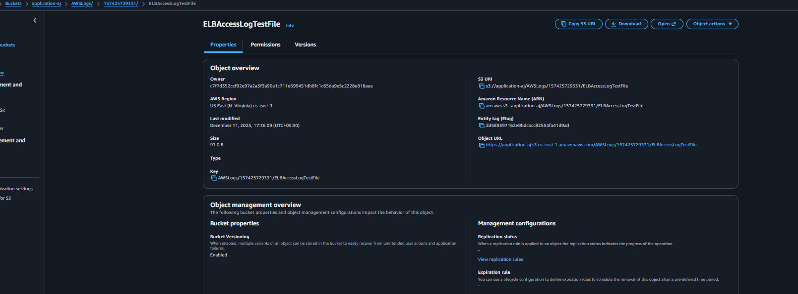

Conculsion: successfully push the application load balancer logs in S3 bucket

